HEATER SPECIFICATION SHEET

1. Electrical Ratings:
Line Voltage | Phase
KW | Control Voltage
Unit Size (A - Z)
2. Area Classification Code (check one):
29 = Class 1, Group B, C & D
Class II, Groups E, F & G
30 = Class I, Groups C & D
Class II, Groups E, F & G
3. Airflow Direction (check one):
Right (U4) | Left (U6)
4. Airflow Through Heater:
Minimum CFM | Actual CFM
Minimum FPM
5. Maximum Inlet Air Temperature (80° F Standard):
°F
6. Temperature Control (check one):
ON/OFF Control
Room Sensing
Duct Sensing
Customer Furnished
SCR Control
Specify Input Signal
Standard 2200 ohm
(from FACTORY thermostat)
(from customer’s thermostat)
135 ohm
4-20 miliamp
0-10 VDC
7. Fan Relay Voltage
24 VAC
120 VAC
Not required if fan relay replaced by option P.

8. Optional Features:
C = Corrosion Resistant Construction
D = Disconnect Switch (heater amp max 60A)
F = Supplementary Fusing (Required > 48A)
G = NEMA 4 Construction (Option D & P not available when Option G is selected)
K = Warning Pilot Light
L = Heater On Pilot Light
M = Disconnecting Contactors
P = Airflow Switch (Specify positive or negative airflow)
Positive Airflow
Negative Airflow
R = Fan Relay when option P is also specified.
9. Special Instructions or Tagging


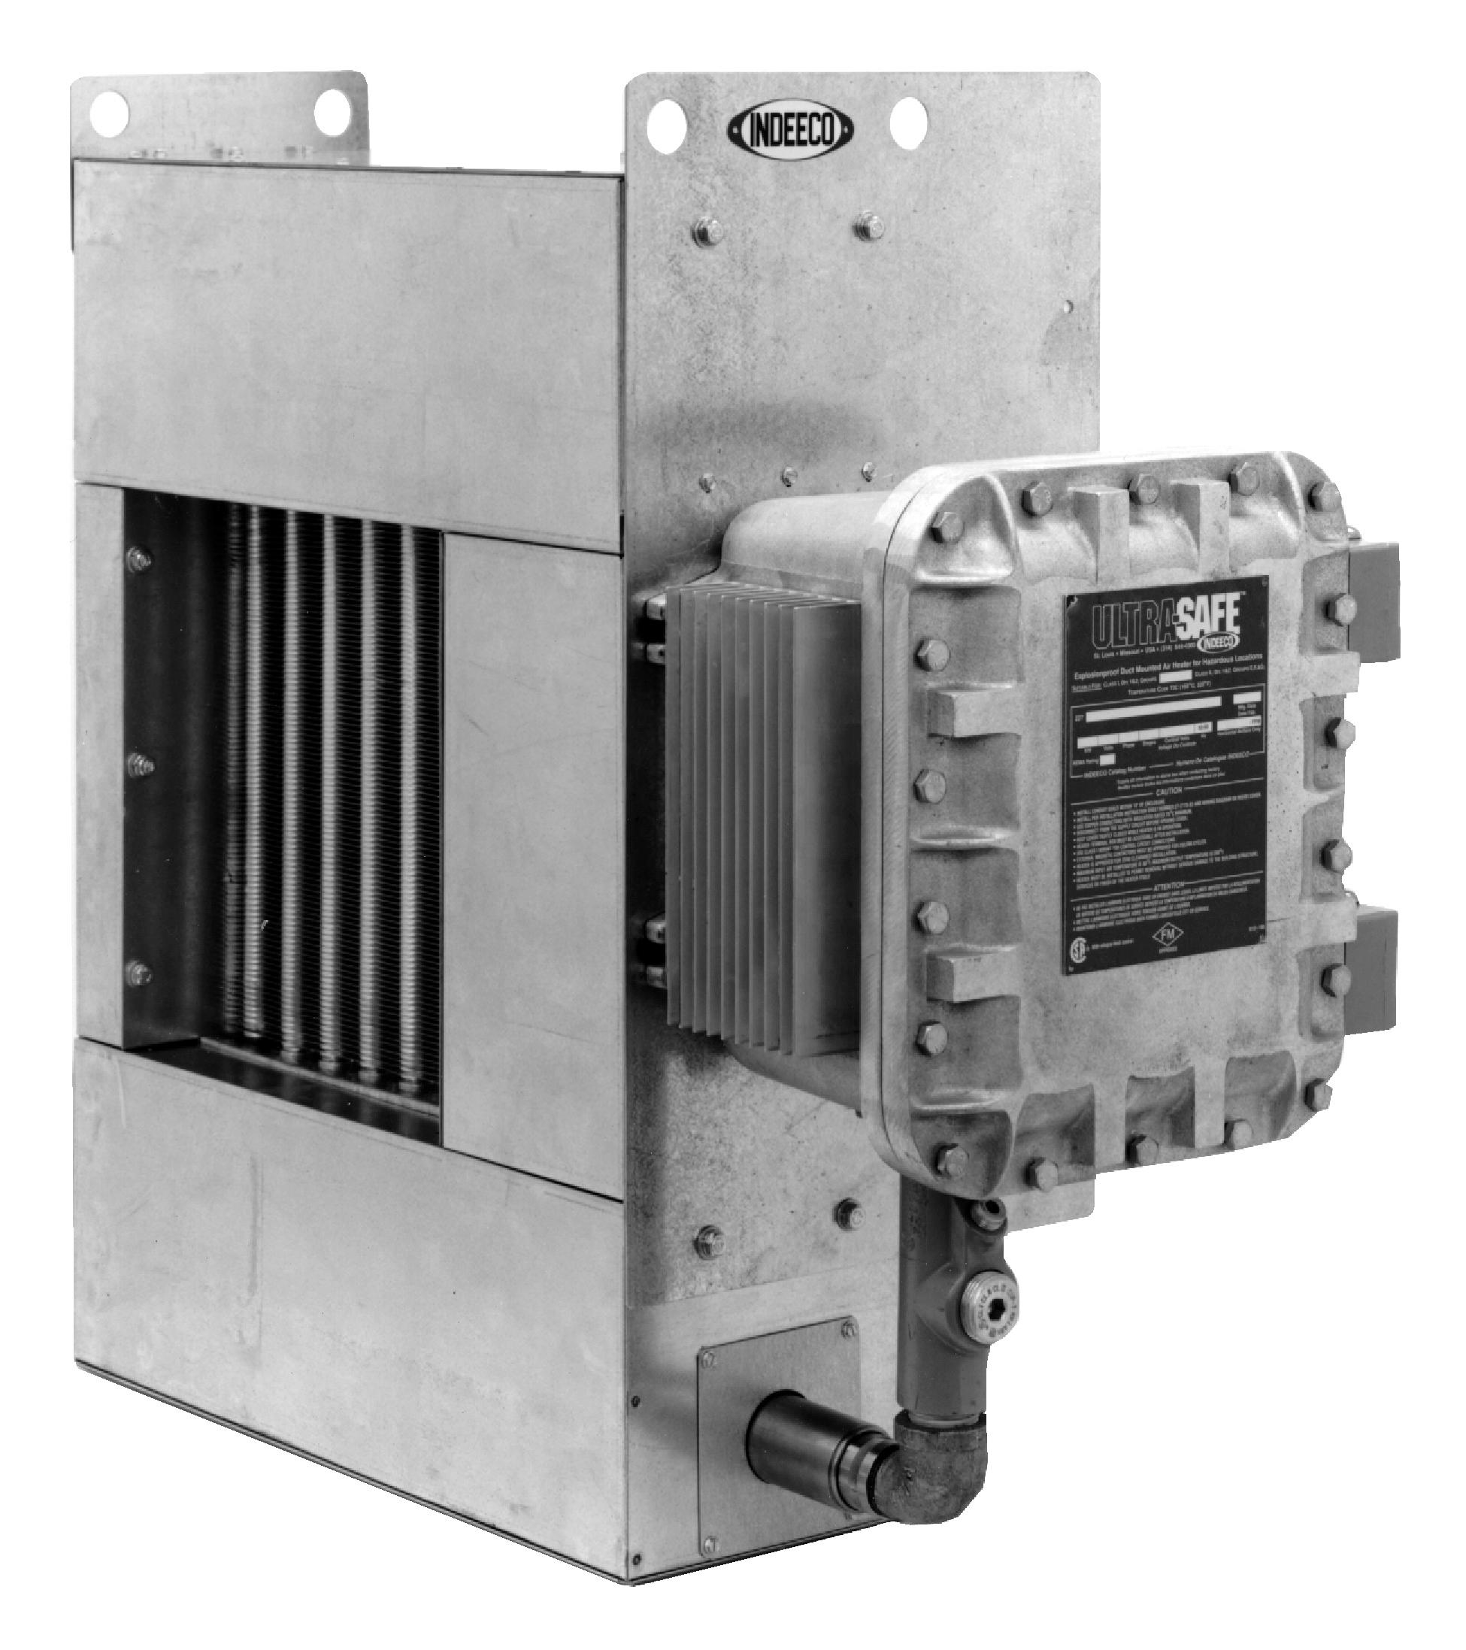

For Installation Operation and Maintenance instructions, visit our website.

sales@heatrex.com

