**Balancing Aesthetics and Functionality in Modern Heating Solutions**

By Andrew Martin, Director of Strategic Marketing at Marley Engineered Products, LLC.

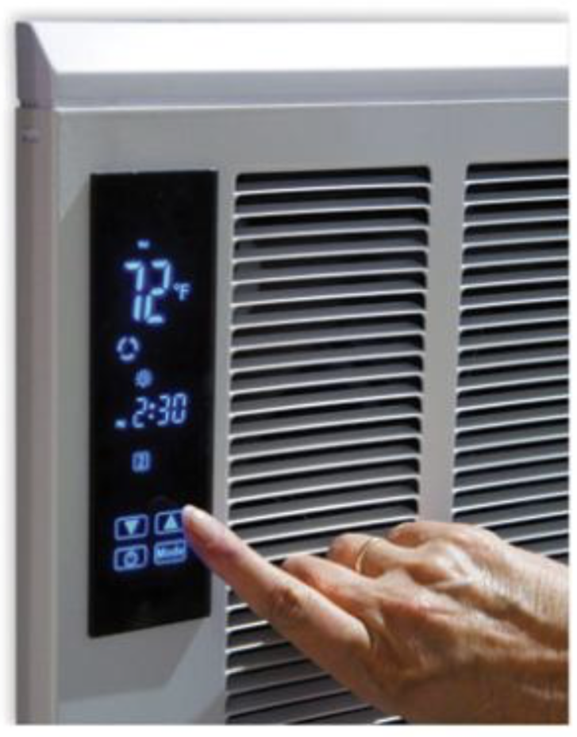

**The Art and Science of Modern Heating**

Modern heating is no longer a matter of simply delivering warmth; it’s about creating environments that blend comfort, efficiency, and aesthetic harmony. In a world increasingly defined by open spaces, sleek architecture, and smart technologies, heating systems must evolve to meet complex demands without disrupting the visual and functional flow of a space.

Over the course of the past several decades in the heating industry, professionals have witnessed firsthand the shifts in priorities among architects, designers, and building managers. Heating is no longer a secondary consideration—it has become central to how people experience space. Striking the right balance between aesthetics and functionality presents both a challenge and an opportunity for innovation in the field.Precision in Motion: High-quality drawer slide systems boast seamless and quiet operation.

**The Push for Invisible Comfort**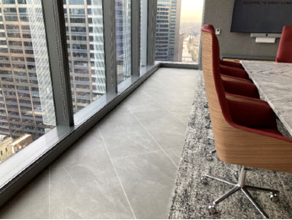

Heating systems have historically been functional but visually obtrusive. Today, the emphasis is on designing systems that are discreet or entirely hidden. Architects increasingly seek solutions that allow the design to take center stage while maintaining thermal performance.

For instance, in spaces like high-rise buildings with expansive floor-to-ceiling windows, the challenge is twofold: preventing heat loss while preserving unobstructed views. Electric convection heaters, often recessed into the floor or integrated within cabinetry, offer a solution by providing targeted warmth without compromising sightlines.

Similarly, outdoor spaces—once considered seasonal—are now being transformed into year-round assets. This is particularly evident in commercial applications like stadiums and hospitality settings. A notable example is the Buffalo Bills’ Highmark Stadium, where a custom infrared system was designed to ensure spectator comfort in frigid conditions. These units combined snow-melting functionality with precise heat distribution, demonstrating how modern heating can overcome spatial and environmental constraints.

**When Customization Becomes Essential**

The versatility of heating systems is often tested in unique spaces where conventional solutions fall short. Customization plays a pivotal role in addressing these challenges, allowing heating systems to meet both functional needs and aesthetic goals.

One striking example comes from the world of luxury yachts. On a high-end vessel, the design required radiant heating panels to be subtly integrated into the outdoor deck area. The goal was to maintain a sleek design while providing warmth for guests enjoying the space during cooler evenings. This project showcased how thoughtful engineering could enhance both comfort and design.Grass’s Elite Plus Undermount Slide System, featuring superior technology for unmatched smoothness and silent operation.

In metropolitan high-rises, convection floor heaters with custom finishes are another testament to how heating can adapt to diverse architectural needs. These heaters often feature bespoke designs, blending seamlessly with interiors while addressing practical needs such as condensation control near large windows.

**The Role of Smart Technology in Heating**

Advances in technology are reshaping how heating systems interact with spaces and their occupants. Smart heating systems, integrated with touch-activated controls and connected to Building Management Systems (BMS), are becoming the norm.

These technologies go beyond aesthetics, offering practical benefits such as energy efficiency and user convenience. For example, smart controls allow building managers to monitor and adjust heating remotely, optimizing energy use while ensuring comfort. This remote capability significantly reduces labor by eliminating the need for manual, individual system checks. Additionally, it minimizes downtime in case of malfunctions, as issues can be detected and addressed promptly. In residential and commercial applications alike, this marriage of technology and design enhances the functionality, sustainability, and operational efficiency of heating systems.

**Sustainability and the Shift Toward Decarbonization**

As the construction industry moves toward greener practices, heating systems must align with evolving sustainability standards. Electrification is at the forefront of this shift, replacing traditional gas-powered systems with cleaner, more efficient electric options.

At the same time, there’s a growing emphasis on material sourcing and manufacturing processes. Heating products are increasingly designed to minimize their carbon footprint, from production to operation. For instance, infrared heating panels not only offer energy efficiency but also align with the aesthetic priorities of modern architecture. Their sleek design and reduced energy consumption make them an ideal choice for eco-conscious projects.

**Aesthetic Challenges in Heating Design**

One of the less-discussed aspects of modern heating is the aesthetic challenge. How do you integrate a functional system into a space without disrupting its design? The answer lies in customization and flexibility. For example, Marley Engineered Products, a leader among engineers and contractors for comfort heating and ventilation systems, recently launched a customizable recessed infrared heater targeted for high-end hotel entryways. This solution allows heating systems to seamlessly blend into the architecture of hotels, while maintaining the necessary thermal output. In such projects, collaboration between engineers, architects, and designers is key to achieving a result that satisfies all parties.

**Bridging Front-of-House and Back-of-House Needs**

While aesthetics are crucial in public-facing areas, industrial and mechanical spaces prioritize durability and performance. Heating systems in these environments must meet strict safety and performance standards.

For instance, unit heaters designed for industrial use often require features like wash-down capabilities or explosion-proof certifications. These systems, though less visually focused, are critical for environments like food processing plants or oil refineries. Balancing these requirements with reliability and cost efficiency is a constant challenge—and one that demands engineering expertise.

**Looking Ahead: The Future of Heating**

The heating industry is at a crossroads, shaped by technological advancements and changing expectations. As buildings become more energy-efficient and regulations push for lower carbon footprints, heating systems must adapt.

The future lies in solutions that offer comfort on multiple levels—thermal, visual, acoustic, and technological. By working closely with designers and understanding user needs, we can create systems that enhance spaces in every way.

Whether it’s a luxury hotel, a bustling office, or an industrial facility, heating is no longer a background concern. It’s a defining feature of how we experience and interact with our environments.

**User-Centric Design: Bridging Comfort and Innovation**

Creating effective heating solutions requires more than engineering prowess—it demands a deep understanding of the spaces these systems will inhabit and the people who will depend on them. At the heart of modern heating design is the ability to listen to users, identify challenges, and craft solutions that address both functional requirements and aesthetic expectations.

The design process often begins with gathering insights directly from the field. Whether through trade shows, customer site visits, or collaborative workshops with architects and specifiers, understanding the nuances of different applications is essential. A recurring theme in these conversations is the desire for heating systems that are unobtrusive, seamlessly integrated into a building’s automation systems, and capable of meeting increasingly stringent energy standards.

For example, recessed heating solutions have gained popularity in response to a demand for clean, uninterrupted lines in modern interiors. By designing convection heaters that sit flush with the floor or fit discreetly within cabinetry, it becomes possible to deliver targeted warmth without detracting from a room’s visual appeal. These heaters often feature customizable finishes, allowing them to harmonize with surrounding materials—a subtle detail that speaks to the broader trend of designing systems to "disappear."

Customization frequently plays a central role in addressing unique needs. In projects like luxury yachts or outdoor hospitality spaces, standard solutions rarely suffice. Radiant ceiling heaters designed to provide warmth for outdoor decks or stadium seating illustrate how innovative engineering can transform seemingly unworkable spaces into areas of comfort. Testing and refining such systems ensures they meet safety and performance standards while aligning with the aesthetics demanded by high-profile environments.

Importantly, these solutions are not just about the products themselves but about the expertise required to implement them effectively. Engineers and designers must work collaboratively, drawing on decades of experience to solve challenges that vary widely across applications. Marley Engineered Products’ approach is rooted in solving such challenges—blending technical precision with a deep understanding of the end user’s experience.

This iterative, user-centric approach is critical as building standards and user expectations continue to evolve. Heating is no longer an isolated system but a core component of how spaces are designed, built, and experienced. By focusing on adaptability, integration, and innovation, modern heating solutions reflect the diverse and dynamic needs of contemporary architecture.

**Final Thoughts**

Heating may seem like a technical concern, but it’s deeply tied to the human experience of space. By balancing aesthetics, functionality, and sustainability, we’re not just designing systems—we’re shaping environments that support comfort, productivity, and beauty.

As the industry evolves, the opportunity to innovate and adapt will only grow. It’s an exciting time to be part of this journey, and I look forward to what the future holds for heating solutions that truly enhance the spaces we inhabit.