Creative Heating Solution at 499 Summit Ave. Earns Christopher Smith and Faber Industrial Technologies the 2025 Silver Fox Award
Smart Value Engineering Helps Maintain Spec and Budget in Jersey City Residential Tower

By: Sean Pesce, Sr. National Sales Manager
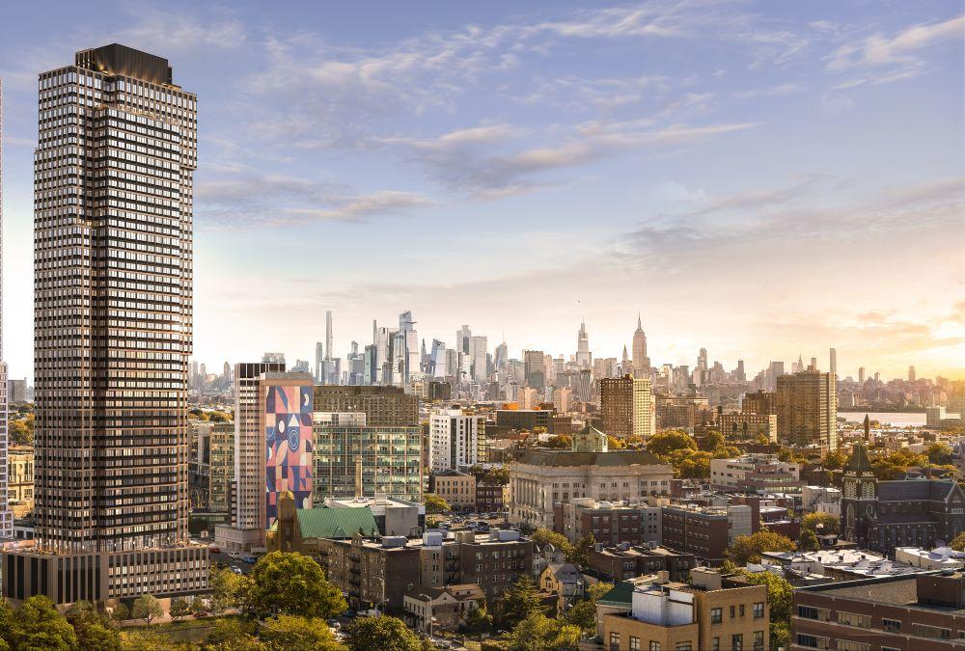
When construction began on 499 Summit Avenue, a new high-rise residential development in Jersey City, the design team at Barone Engineering already had a trusted HVAC partner in mind, QMark®, specified for its performance, flexibility, and reliability in demanding building environments. But winning the bid wouldn’t be easy. As multiple distributors began quoting comparable products from both QMark and various competitors, cost quickly became a sticking point.
Enter Christopher Smith of Faber Industrial Technologies, a manufacturer’s rep agency located in Clifton, NJ who has built a reputation on more than just delivering quotes, they solve problems. Working closely with Turtle & Hughes, a regional electrical distributor, Smith helped secure the project and deliver a heating system design that honored the engineer’s spec, met the contractor’s budget, and demonstrated the kind of responsive ingenuity that defines Marley Engineered Products’ Silver Fox Award.
499 Summit Ave is reshaping the Jersey City skyline
“From the start, this project was highly competitive,” said Smith. “But our relationship with Barone Engineering and our ability to offer intelligent value-engineering through QMark products gave us a strategic edge.”
Smart Substitutions, Seamless Collaboration
The original spec called for a mix of ceiling and wall mounted electric heaters across multiple zones of the high-rise, including tenant corridors, back-of-house spaces, and mechanical areas. Faber identified several opportunities for value engineering, particularly in product swaps that preserved performance without compromising the design intent.
For example, by switching from the initially specified CWH3000 units to CZ2048T and CWH1207DSF models, both from QMark, Faber was able to provide equivalent wattage and voltage in a more cost-effective package. The team also recommended minor adjustments to thermostat kits and mounting configurations to streamline installation and minimize labor costs.
“With a little extra help from Marley’s team, we were able to fine-tune the order to meet the contractor’s budget,” Smith said. “In the end, our distributor and the contractor both felt like they won. They maintained spec, came in under budget, and avoided unnecessary redesign work.”
Performance-Driven Product Selection
The final equipment package included more than thirty product lines tailored to meet the diverse heating needs across the 499 Summit development. Among the key selections were QMark’s QCH1202F ceiling heaters, compact, quiet units ideal for tenant corridors and common areas, and multiple 480V MUH series unit heaters (MUH0541, MUH0341, MUH074), which offered rugged, high-capacity performance for mechanical rooms, stairwells, and larger open spaces.
For freeze protection in concealed or inaccessible ceiling areas, Faber recommended CHPR25 plenum-rated units, which met local code requirements while maintaining clean architectural lines. A corrosion-resistant QWD washdown heater with 5kW output and 24V controls was specified for the building’s high-moisture environments, and heavy-duty CUH cabinet unit heaters were deployed in utility rooms, offering up to 10kW of ducted airflow capacity.
The package was rounded out with a full suite of thermostats, mounting brackets, and field-install kits, ensuring a complete, coordinated installation. Every piece of equipment was delivered on time and configured to spec, backed by Marley Engineered Products’ reputation for reliable, durable solutions.

A Win for All Parties
The scope of the heating installation at 499 Summit, spanning more than 90 unique equipment line items, represents a major achievement in specification support and cross-channel coordination. The project is now slated for completion in 2026 and is part of a growing portfolio of high-rise residential developments reshaping Jersey City’s skyline.
“This project helped drive Turtle’s monumental growth in 2024,” said Smith. “It also reinforced Faber’s standing as a trusted partner to engineers, distributors, and contractors alike.”
For his role in the successful bid, creative problem-solving, and commitment to specification integrity, Christopher Smith has been honored with the 2025 Jim Herring Memorial Silver Fox Award, presented annually by Marley Engineered Products.
“This award embodies the spirit of Jim Herring, who had a talent for finding creative solutions to specialized HVAC challenges,” said Sean Pesce, Sr. National Sales Manager for Marley Engineered Products. “Christopher and the Faber team exemplified that spirit by turning a competitive bid into a collaborative success. We’re proud to recognize their work.”

